DOCKER TASK 2

Q: Create a dockerfile, docker-compose file which when executed must display your basic details in the website.

OUTPUTS:

Launched instance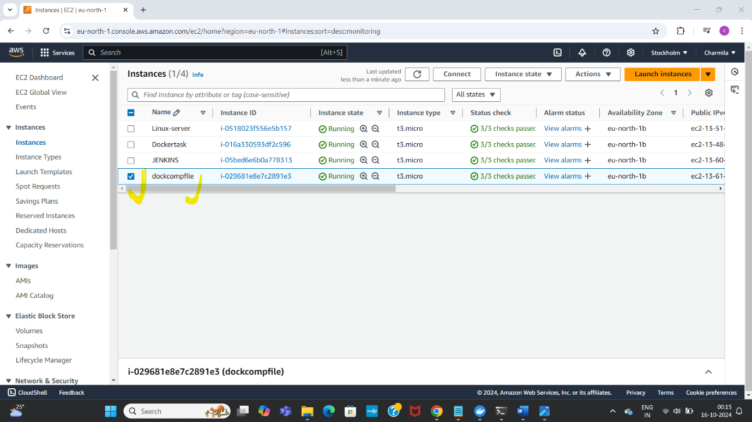

Established connection

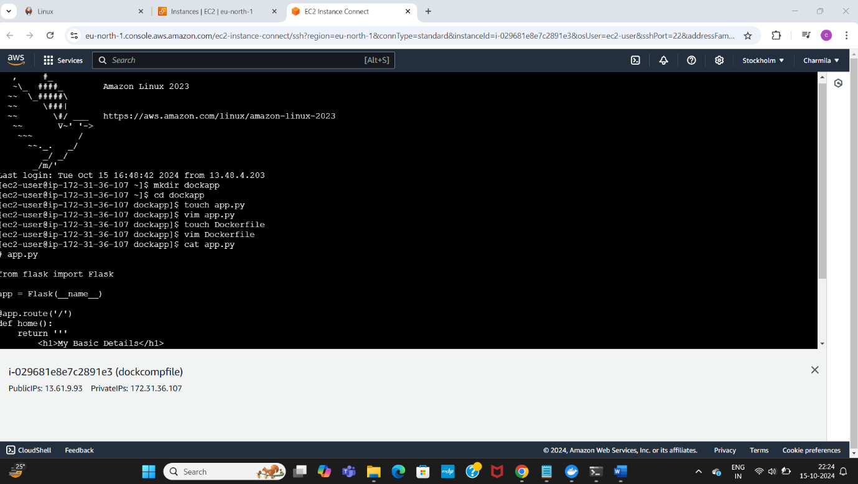

Installed docker , created a directory myapp, created a file app.py-imported instructions to it using vim editor

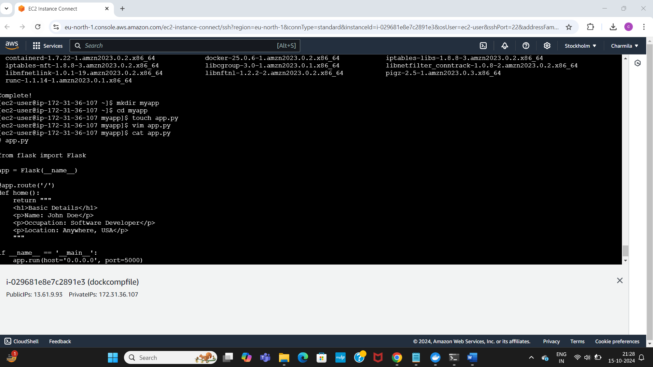

Created a dockerfile, copied instructions to it a text using vim editor

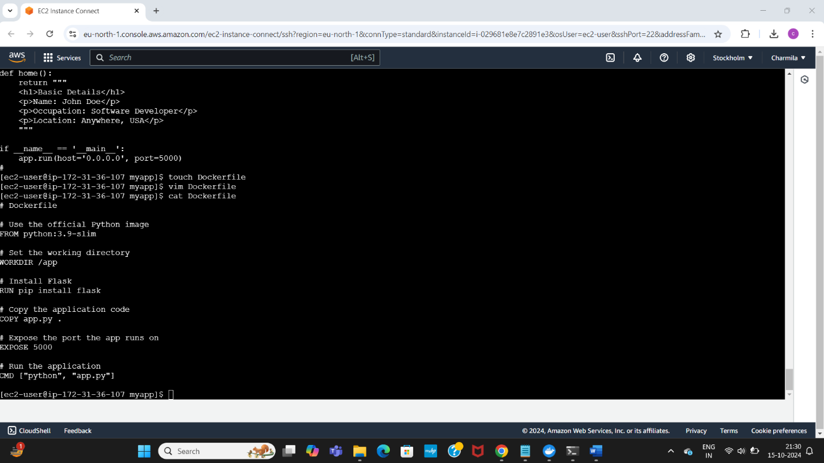

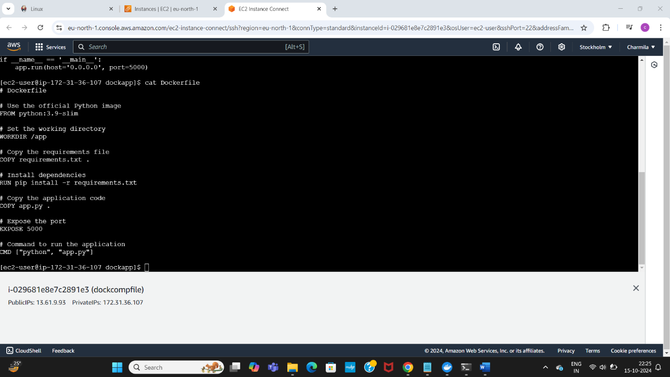

Installed docker, docker compose-latest version

Checked status, started it

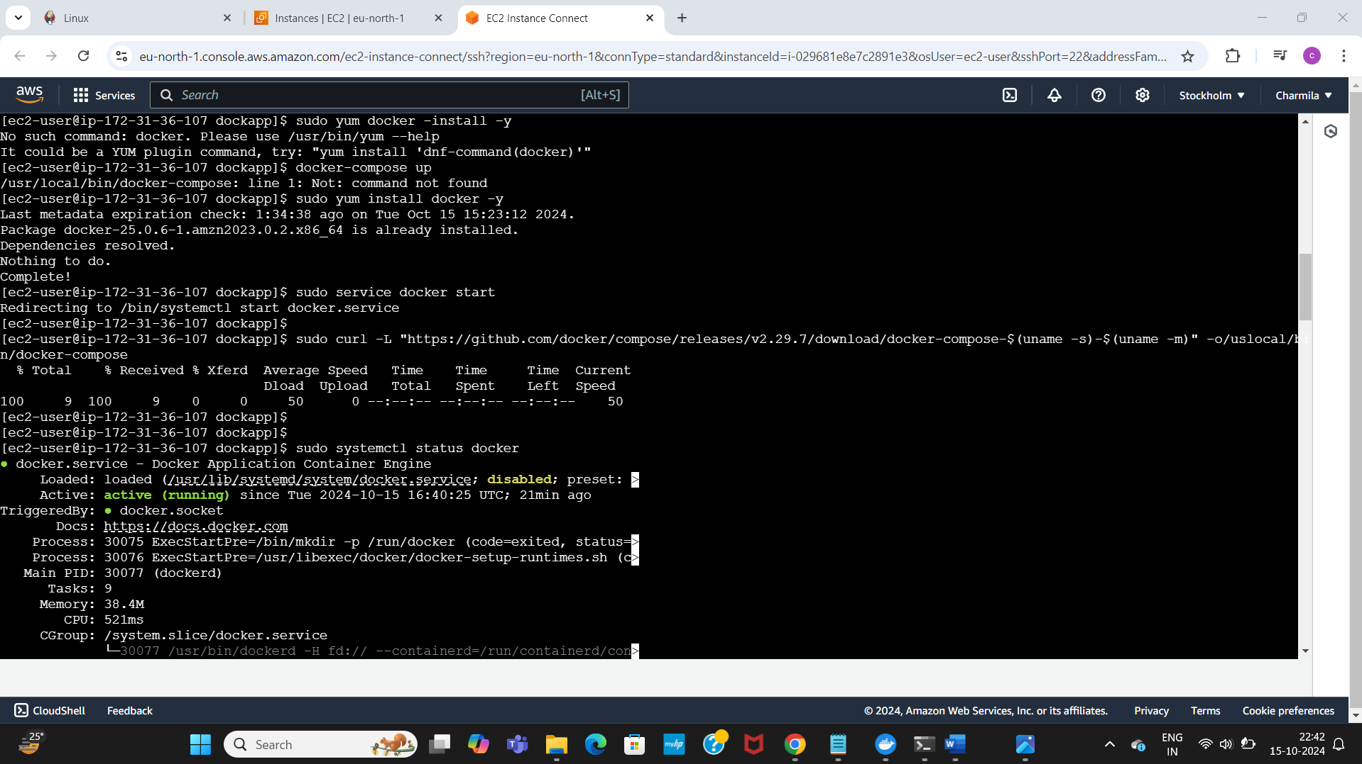

Executed the command sudo docker-compose up –build -d for detached mode

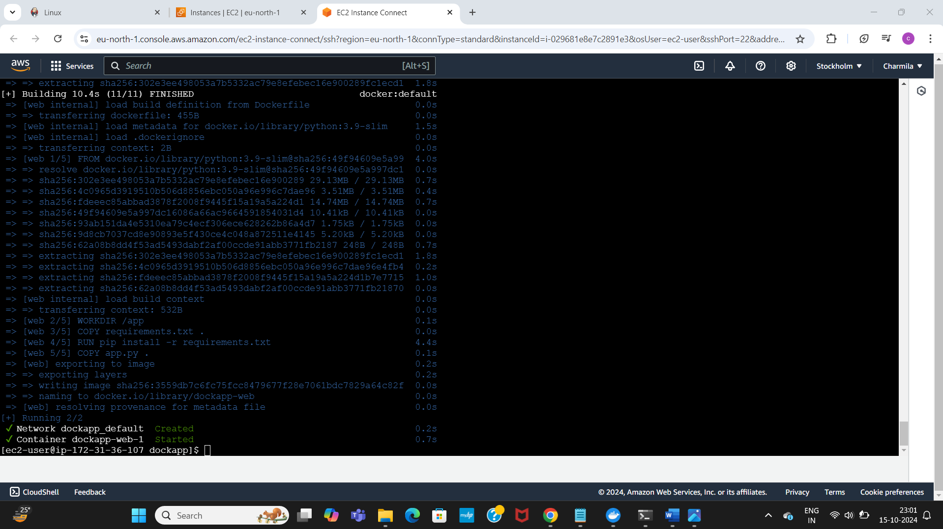

Checked docker compose version, if it is running or not

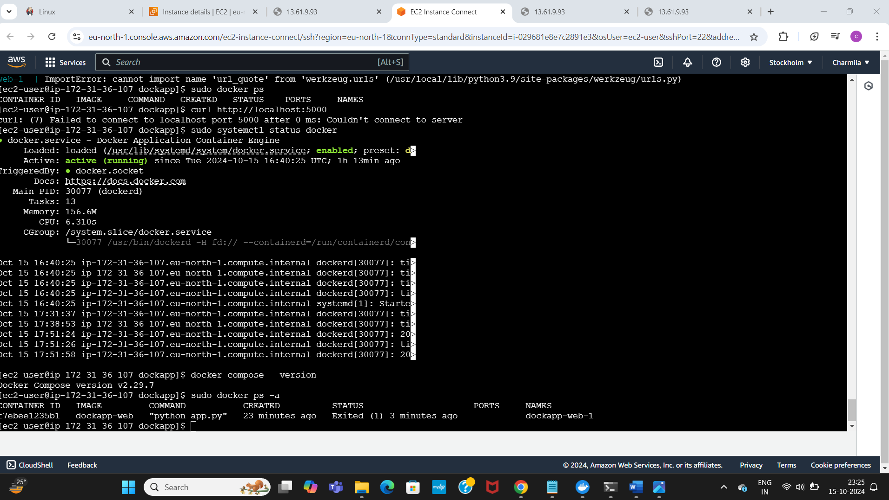

Installed httpd, re checked docker status, restarted it, started and enabled httpd

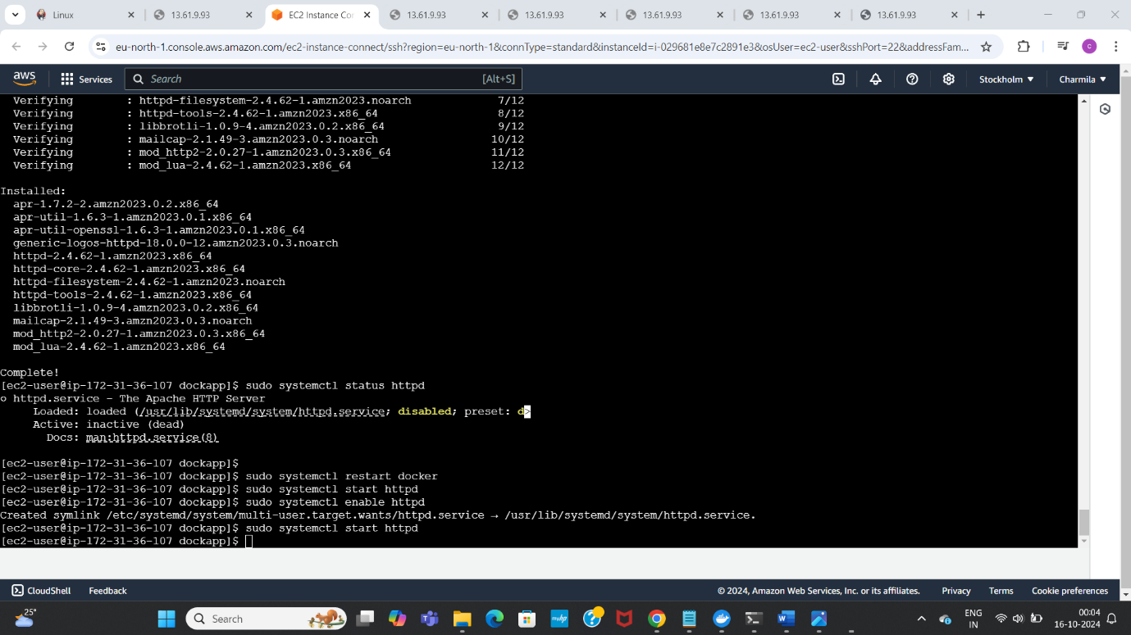

Opened in web browser

